Welcome
to
Preschool Chaddlewood

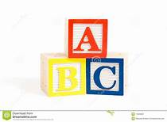

We aim to create a warm, safe and stimulating environment
within a culture of respect enabling children to develop
through play and setting their foundation
for their journey through school
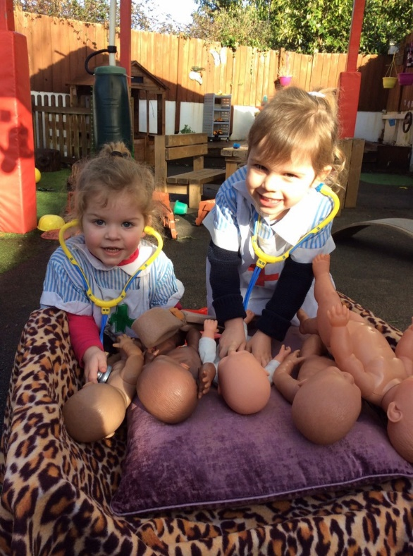

Awarded ‘GOOD’ by Ofsted in January 2020

CHADDLEWOOD PRE-SCHOOL AND WOODIES
OUT OF SCHOOL CLUB

WESTFIELD, PLYMPTON, PLYMOUTH, DEVON. PL7 2EU
Telephone 01752 345838/231325
www.chaddlewood-preschool.org.uk
email – preschool@chaddlewood-preschool.org.uk

Our Commitment
We provide a safe and stimulating environment for your child, where they can explore and learn through play. We recognise that every child is unique, learning and developing in different ways and at different rates. You, the parent and carer, are your child’s first educator and we value the partnership between us, helping your child learn and develop in ways that reflect their particular likes to influence our provision and planning for activities to extend their learning, to encourage their development.
We work together and alongside members of the local community, valuing the importance it plays on children’s development. We offer children and parents a service which promotes equality and values diversity, operating from an ethos of tolerance and respect.

The setting
We operate from two buildings, the bungalow for 2–3-year-olds and the hut for 3–4-year-olds. Each building is equipped with an outdoor area, providing opportunities to explore the natural environment. We grow flowers, fruit and vegetables throughout the year. Each building offers a range of resources encouraging imagination and creativity. We are a charity and run by a management committee of parents who enjoy having input and ideas into the setting.
We also run an out of school club, called Woodies. Available to children aged 2-11 years old.
We offer ME2, 2 and 3-4 year old 15 hour and 30 hour funding, subject to eligibility and availability.
Opening Hours
The pre-school operates Monday to Friday from 9.00am-3.15pm term time only

Session times are:

Preschool
Morning session 9.00-12 noon
Lunch club 12 noon-12.45pm
Afternoon session 12.45pm-3.15pm
Woodies
Breakfast club - 7.30am until the start of school.
After school Club - End of school until 6.00pm.
Please contact Kelly on woodies@chaddlewood-preschool.org.uk for more details

The Sessions, Routine and Staff
Each session is provided with opportunities to learn and develop which reflect the children’s interests and learning styles. As well as planned activities we encourage children to make their own choices, ensuring that the children have independent access to the resources. We evaluate each session, and use these to develop play and learning further. We enable children to feel safe and secure in our environment by routines such as snack, story and time for small adult led group work. We ensure each child feels valued and has a personalised tray for their belongings and creations which they can access independently throughout the day. We believe that our qualified and experienced staff are our greatest asset. Each building has a deputy manager on site who are Claire Kerswill and Sarah Aubury. The preschool has a clear staff structure with designated roles which improves effectiveness and accountability:

Our management team are:

Jane Bartlett Manager, Early Years Professional, Safeguarding Lead, NPQEYL
Victoria Methven, Business Manager,
Sarah Aubury (Deputy Manager (Hut), SENco),
Claire Kerswill (Deputy Manager (BUNGALOW), Deputy SENco)

Keypersons:
Shannon Lloyd, Shauna Toy, Frances Airton, Nikki Sprague, Laura Hill

Apprentices:
Skye Holmes, Chloe Porter

Woodies- Kelly Tomlinson (Deputy Manager (WOODIES), Karen Hillyer, Lauren January, Amanda Fifield, Amy Cooper

Mealtime Assistant- Amy Cooper, Karen Hillyer

If you would like to put names to faces, please visit our website
www.chaddlewood-preschool.org.uk and look on our staff page
Learning and Development
Our provision for learning and development is guided by Development Matters and Birth to Five matters. As a setting we embrace this guidance which is committed to raising the outcomes of children aged 0-5.
‘All children develop in different ways and development is not a linear or automatic process. It depends on each unique child having opportunities to interact in positive relationships and enabling environments that encourage their engagement and recognise their strengths’ (Birth to Five Matters Page 6)
At Chaddlewood Pre-school we recognise that each child is unique. We use a Keyperson system which promotes a supportive relationship and provides consistency. Keyperson’s work with parents of the children in our care to ensure our planning reflects the needs and interests of the children ensuring that the activities we provide are stimulating, challenging and age appropriate. The keyperson understands your child by means of observation and assessment. The children are observed and these are documented in our online learning journal –Tapestry. These will include photographs, videos and a brief explanation into the learning that has occurred. These are available for you to view by logging onto their profile, through your phone, tablet or computer

SEN
Early intervention is imperative to improving outcomes for children and a few minutes each day of individual work may make all the difference to your child. Our Special Educational Needs Co-ordinator is Sarah Aubury (hut) and she is available to help us all identify activities/strategies to help your child develop. Sarah is also supported by a deputy, Claire Kerswill (bungalow).

Snacks and Meals and Allergens
We provide drinking water throughout the session and offer milk at snack and lunch time. We are also able to offer a two-course hot lunch prepared by Chaddlewood School kitchen at the cost of £1.90 per meal. These are booked in advance on a termly basis and will be added to your invoice. (Please note there are NO REFUNDS due to sickness or absence) You are also welcome to bring a packed lunch if staying for the lunchtime session.

We encourage healthy eating by having fresh fruit at snack time. There may be an exception to this if it supports learning or personal and social development. We view snack time and lunch time a social event where children and adults sit together. We encourage independence and the children pour their own drinks, put their plates away and serve the food. We use real crockery in both buildings and this encourages the children to handle it carefully and it shows respect for our equipment.

May we also request that where possible any foods containing nuts are not included in the contents of lunch boxes due to allergies. Please advise us of any allergies your child has. Also due to choking hazards please ensure all spherical foods like grapes and cherry tomatoes are cut into quarters.

Information
Each week we will electronically send a weekly newsletter via Tapestry. This allows you to see what we have/what we will be 5doing. We also supply your child with a book bag and wet bag which you will be invoiced £15. This allows for the setting keep letters and art work safe.

Policies and procedures and latest Ofsted report are also always available on hard copy in the setting or on our website at www.chaddlewood-preschool.org.uk
Please look out for new notices about various issues including events and safeguarding.

Safeguarding
Our commitment to safeguarding is discussed in detail during the induction process. We have a duty of care and protection of the children we look after. We update our training regularly, adapting our procedures to improve safeguarding. The Safeguarding Lead is Jane Bartlett.

Toileting
Your child does not need to be toilet trained to be able to attend preschool. We appreciate that children toilet train at different ages. We aim to support this process by liaising with you and where possible adopting the same procedures e.g. rewards, star charts etc. Children are welcome to our setting when still in nappies, all we request is that supplies of nappies, baby wipes, spare clothes etc are provided.

Sickness and Medicines
Children will play and learn if they are feeling well and happy, but we are aware that there may be occasions when they are under the weather and still attend the setting. We request, however, that children stay at home if they are unwell, for their own well- being and to avoid the spread of germs. Children must stay at home for 48 hours after their last bout of sickness and/or diarrhoea. Children taking antibiotics or medication they have not had before must stay at home for the first 24 hours, ensuring they do not have an allergic reaction to the medication. We can administer prescribed medication but consent forms MUST be completed first. Children who may have an ongoing illness such as asthma, eczema or require Epipen or other treatment, parents will be asked to complete a health care plan.

Supervised Toothbrushing
The supervised tooth brushing programme is specifically designed for children under the age of 5. This is the best age to introduce correct tooth brushing technique and form good behaviours, which will last a lifetime. The children learn to brush their teeth themselves, correctly. By setting up a supervised tooth brushing programme in school/nursery, it allows the children to incorporate it into their daily routine and follow the good practice at home.
Our staff are fully trained and we supply toothbrushes and toothpaste.

Session and Lunch Club Fees

Morning Session (9am-12am) 3yrs old £17.40 2yrs old £ 20.40
Afternoon Session (12.45pm-3.15pm) 3yrs old £14.50 2 yrs old £ 17.00
Lunch Club (12pm-12.45pm) £4.35 £ 5.10

Fees are payable monthly in advance. Invoices are issued electronically (if you would prefer a paper copy please ask) to parents/carers and must be paid within seven days. Fees must be paid for all booked sessions even if your child is absent for a short period e.g. holidays or illness. We require two weeks’ notice of any changes/permanent cancellation of sessions. If two weeks’ notice is not given fees must be paid.

Additional Fees
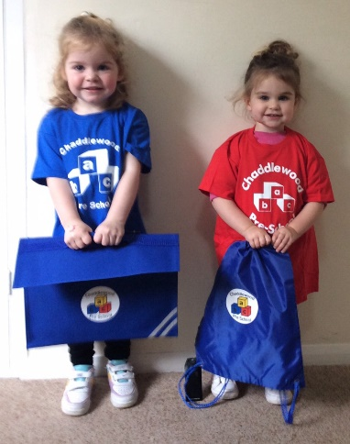
- There is a booking fee of £25 when you enrol your child. This will be returned to you when your child starts at Chaddlewood Preschool. N.B. This fee does not guarantee a place or reserve sessions.
- From January 1st 2024 we have introduced a consumable fee to cover snacks, suncream, cooking, toothbrushes, toothpaste and wet wipes etc. This will be £10 per term (optional)
- On starting preschool your child will be issued with a book bag and wet bag this is charged at £15 and will be added to your invoice.
- Chaddlewood Preschool also sell T-shirts and Sweatshirts (optional) if you would like to purchase them, please contact a member of staff.
Funded sessions
My child is 2:
There are two funding options if your child is two:
- ME2 funding – This is available if the family earns less than £16,190, the family is on certain benefits, the child is ‘looked after’ by the local authority, they have an Education, Health, and Care plan (EHC), receive Disability Living Allowance (DLA), have left care to be adopted or placed under a special guardianship or child arrangement order or are children of Zambrano carers.

Please visit this website to find out further information:
www.plymouth.gov.uk/free-childcare-places-eligible-two-year-olds

- 15hrs working-family funding – At present the government offers 15 hours a week free early-years education for two-year olds, for working families. This means if both parents are working at least 16 hours a week, or if a single parent is working at least 16 hours a week, you should be eligible. You need to apply for this through www.childcarechoices.gov.uk where, if eligible, you will be provided with a code.

Please visit this website to find out further information:
www.gov.uk/check-eligible-free-childcare-if-youre-working
My child is 3 or 4:
There are two funding options for three and four-year olds:
- All children receive 15hours free early-years education from the term after their third birthday. There is no eligibility criteria for this and you do not need to apply for a code to be entitled to this.

- 30hrs working-family funding – At present the government offers 30 hours a week free early-years education for three and four-year olds, for working families. This means if both parents are working at least 16 hours a week, or if a single parent is working at least 16 hours a week, you should be eligible. You need to apply for this through www.childcarechoices.gov.uk where, if eligible, you will be provided with a code.

I am entitled to working-family funding, is there anything else I can claim to help with childcare costs?
If you are eligible for the working-family funding then you are likely to be also able to apply for tax-free childcare. To claim this, you need to set-up a tax-free childcare account online. The way this works is for every £8 you pay into your tax-free account the government pay in £2. You can combine this with the working-family entitlement to cover any additional childcare costs.
Please visit this website to find out further information:
www.gov.uk/tax-free-childcare

The First Few Days
Your child will need to bring a named water bottle, a full change of clothes (named), nappies and wipes (if applicable) and clothing suitable for the weather. On your child’s first day we also ask you to bring in your child’s birth certificate and health visitors’ red book for administration purposes.
We understand that all children and families cope differently with change. Our intention is to make this an easy and happy transition for everyone. We will have established what your child’s favourite activities and toys are and we will use this information to plan activities personally for them. We welcome items of comfort from home (please label them) and we will listen to your views on how best to support your child during this settling in period.
We look forward to welcoming your child into Chaddlewood Preschool. If you have any further questions, please feel free to call in, or telephone us. We would be happy to help.
Our contact information
Administration- Victoria on 01752 231325 or preschool@chaddlewood-preschool.org.uk
Bungalow (2-3yrs) 01752 345838 (Mrs Kerswill and Mrs Bartlett)
Hut (3-4yrs) 01752 231325 (Mrs Aubury)
Woodies- Kelly 01752 231325 or woodies@chaddlewood-preschool.org.uk

